
MACAU UNIVERSITY OF SCIENCE AND TECHNOLOGY

School of Computer Science and Engineering
Faculty of Innovation Engineering

Final Year Project Proposal

Title: Analysis of Motion Intensity in Michelson Interference Fringes Using Computer Vision and YOLO Model

Student Name : Liao Jionyi
Student No. : 1220011562

Supervisor : Li Jianqing

September, 2025

Abstract
This study proposes a novel deep learning-based approach for analyzing the motion intensity of Michelson interference fringes. By integrating computer vision techniques with temperature variation analysis, we systematically investigate the influence of dynamic temperature changes on fringe motion. A total of 49,984 high-resolution images were collected across a temperature range of 30.8–46.1°C. Using the YOLOv12s object detection model, we achieved automatic fringe tracking with an mAP@0.5 of 50.3%, precision of 90.5%, and recall of 36.7%. A 12-dimensional feature space was constructed from 1,681 interpolated temperature samples. Results show that the rate of temperature change is positively correlated with fringe motion intensity ($r=0.011,P=0.014$), while absolute temperature exhibits a negative correlation ($r=−0.021,P<0.001$). A random forest model significantly outperformed linear regression ($R²=0.6209vs.0.0451$), with dynamic temperature features contributing 64.61% of total importance. This work demonstrates the feasibility of using deep learning for quantitative fringe motion analysis and establishes a predictive framework for thermo-optical interference behavior.
Keywords: Michelson interference; fringe motion; YOLOv12s; deep learning; temperature variation; random forest

Table of Contents

Abstract 1
1. Introduction 3
2. Objectives 4
3. Related work 5
3.1 Evolution of YOLO Algorithms for Object Detection 5
3.2 Application of YOLO in Optical Measurement and Interferometry 6
3.3 Gaps in Fringe Detection and Environmental Modeling 6
4. Methodology 7
4.1 Overall framework and system architecture 7
4.2 Temperature Data Interpolation 8
4.3 YOLO model development and training strategy 9
4.3.1 Customize YOLO architecture 9
4.3.2 Customized Non-Maximum Suppression (NMS) 9
4.3.3 Training Strategy 9
4.4 Multi-Task Composite Loss Function 10
4.5 Exercise intensity calculation and analysis 11
4.5.1 Strip Tracking Algorithm 11
4.5.2 Motion Status Classification 12
4.6 Machine learning model construction and evaluation 12
4.6.1 Model Architecture Comparison 12
4.6.2 Performance index 13
4.7 Statistical Analysis Framework 14
4.7.1 Correlation analysis 14
4.7.2 Hypothesis Testing 14
5. Required hardware and software 15
6. Project planning 16
References 16

1. Introduction
The Michelson interferometer, first developed by Albert A. Michelson in 1881[1], has long been recognized as a cornerstone of precision optical measurement instruments in the history of physics. Originally conceived to investigate the existence of the luminiferous ether in the Michelson-Morley experiment, this interferometer has since evolved into a fundamental tool for high-precision measurements across diverse scientific and engineering disciplines. The core principle of the Michelson interferometer involves the interference of coherent light beams split by a beam splitter and reflected from two perpendicular mirrors, generating characteristic interference fringes that are highly sensitive to minute optical path differences. These fringes serve as visual indicators of subtle changes within the optical system, enabling the detection of displacements, refractive index variations, and environmental perturbations with sub-wavelength precision.
Despite its significance, traditional fringe analysis methods have long been plagued by several critical limitations. Manual observation and rudimentary image processing techniques, which have been the mainstays of fringe analysis, are inherently subjective, time-consuming, and prone to human error, especially when dealing with dynamic fringe patterns or extended measurement periods. Conventional image processing methods, while offering some degree of automation, typically rely on threshold-based algorithms and simple edge detection techniques. These methods struggle with varying illumination conditions, noise, and complex fringe geometries, often requiring extensive parameter tuning for different experimental setups and lacking the robustness needed for real-time applications. Moreover, traditional approaches provide limited quantitative analysis capabilities, making it difficult to establish precise relationships between environmental factors and fringe motion characteristics.
The advent of computer vision and deep learning technologies has revolutionized numerous fields, including optical measurements and precision instrumentation. Convolutional Neural Networks (CNNs) have demonstrated remarkable success in image recognition, object detection, and pattern analysis tasks, offering unprecedented accuracy and automation capabilities. In optical metrology, researchers have begun exploring machine learning approaches for various applications, such as laser speckle analysis, holographic reconstruction, and optical surface inspection. However, the application of state-of-the-art deep learning models to interference fringe analysis remains largely unexplored, presenting a significant opportunity for innovation in precision measurement techniques.
Among the various deep learning models, You Only Look Once (YOLO) has emerged as a game-changer in object detection, offering real-time performance without compromising accuracy. Unlike traditional two-stage detection methods, YOLO processes the entire image in a single forward pass, making it exceptionally suitable for dynamic applications. The latest YOLO architectures, including YOLOv12s, incorporate advanced features such as attention mechanisms, feature pyramid networks, and optimized anchor-free detection, resulting in superior performance in detecting small objects and handling complex scenes. These characteristics make YOLO particularly attractive for interference fringe detection, where rapid, accurate identification of fringe patterns is crucial for real-time monitoring and analysis.

2. Objectives
This study presents the first comprehensive application of deep learning technology to Michelson interference fringe motion analysis, establishing a novel paradigm for automated optical measurement systems. The primary innovation lies in the integration of YOLOv12s object detection with quantitative temperature change rate analysis, creating a unified framework for understanding the relationship between environmental thermal dynamics and fringe motion intensity.
Our research objectives include:
- Developing an automated fringe detection and tracking system using state-of-the-art deep learning models,
- Establishing quantitative relationships between temperature variations and fringe motion characteristics,
- Constructing predictive models for fringe motion intensity based on multi-dimensional feature analysis,
- Validating the physical hypothesis that temperature change rates dominate fringe motion behavior.
The significance of this work extends beyond technical innovation to fundamental scientific understanding. By providing the first quantitative analysis of temperature-fringe motion relationships using machine learning approaches, this research offers new insights into thermo-optical effects in precision measurements. The developed methodology has broad applications in precision metrology, optical detection systems, industrial quality control, and environmental monitoring. Furthermore, the integration of deep learning with classical optical interferometry represents a significant step toward intelligent measurement systems that can adapt to varying experimental conditions and provide real-time analysis capabilities.
The comprehensive dataset of 49,984 high-resolution frames coupled with detailed temperature measurements (30.8-46.1°C) provides an unprecedented foundation for understanding interference phenomena under controlled thermal conditions. The machine learning models developed in this study, particularly the random forest predictor achieving ${\text{R}}^{\text{2}}\text{=0.6209}$, demonstrate the potential for accurate motion intensity prediction based on thermal dynamics. This work establishes a new standard for automated interference analysis and opens pathways for future research in AI-assisted precision measurements.

3. Related work

3.1 Evolution of YOLO Algorithms for Object Detection
The You Only Look Once (YOLO) framework, introduced by Redmon et al. in 2016, marked a paradigm shift in real-time object detection by framing detection as a single regression problem [2]. Unlike traditional two-stage detectors such as R-CNN [3], YOLO performs object localization and classification in one forward pass, enabling superior speed-performance trade-offs. Subsequent versions have progressively enhanced accuracy and robustness. YOLOv2 introduced anchor boxes and batch normalization, improving recall and localization [4]. YOLOv3 adopted a multi-scale feature extraction strategy using a Darknet-53 backbone, enhancing detection of small objects [5]. YOLOv4 incorporated techniques such as Mosaic augmentation and CSPDarknet53 to optimize both speed and accuracy [6]. YOLOv5 further refined model compactness and deployment efficiency, becoming widely adopted in industrial applications [7]. More recently, YOLOv8 and YOLOv12 have introduced architectural innovations such as anchor-free detection and advanced attention mechanisms, achieving state-of-the-art performance in general-purpose object detection tasks [8].

3.2 Application of YOLO in Optical Measurement and Interferometry
Despite its widespread use in natural image domains, the application of YOLO in optical metrology—particularly in interferometric fringe analysis—remains limited. Traditional fringe detection techniques rely on gradient-based methods, Fourier transform, or phase-shifting algorithms, which are sensitive to noise and require manual parameter tuning. Recent efforts have explored deep learning for fringe pattern analysis. For instance, fully convolutional networks (FCNs) and U-Net architectures have been employed for fringe denoising and phase extraction [8, 9]. However, these methods primarily focus on static fringe patterns and lack the capability for real-time detection and tracking.
A few recent studies have begun to explore the potential of YOLO in optical inspection tasks. In [10], YOLOv5 was applied to detect defects in laser speckle patterns with high accuracy and real-time performance. These works suggest that YOLO-based detection holds promise for interferometric applications, but they fall short of addressing the full complexity of real-world fringe behavior, including motion, deformation, and environmental coupling.

3.3 Gaps in Fringe Detection and Environmental Modeling
To date, no study has systematically applied the latest YOLO architectures (e.g., YOLOv12) to the detection and tracking of Michelson interferometer fringes, nor has any work integrated environmental factor modeling (e.g., temperature drift) into the fringe motion analysis pipeline. Existing methods remain constrained by:
- Low adaptability to noisy or low-contrast fringe images
- Lack of quantitative analysis of fringe motion under environmental perturbations
- No integration of environmental metadata (e.g., temperature change rate) into the detection model

While YOLO-based detection has achieved remarkable success in general computer vision tasks, its potential in high-precision optical measurement, particularly for dynamic interferometric fringe analysis, remains largely unexplored. Moreover, the influence of environmental factors on fringe behavior has not been incorporated into any existing deep learning-based detection framework. This work addresses these gaps by proposing a novel YOLOv12s-based real-time fringe detection and tracking system, coupled with a quantitative model linking fringe motion intensity to temperature variation, aiming to enhance both the accuracy and environmental robustness of Michelson interferometer measurements.

Methodology

4.1 Overall framework and system architecture
Our methodology employs a comprehensive approach that integrates computer vision, deep learning, and statistical analysis to investigate the relationship between temperature variations and interference fringe motion in Michelson interferometers. The system architecture consists of four main components:
- Data Acquisition Module : Captures high-resolution interference fringe images and synchronized temperature measurements
2. YOLO-based Detection Module : Automatically detects and tracks interference fringes using a customized YOLOv12s model
3. Motion Analysis Module : Calculates fringe motion intensity and analyzes movement patterns
4. Statistical Modeling Module : Establishes predictive models linking temperature dynamics to fringe motion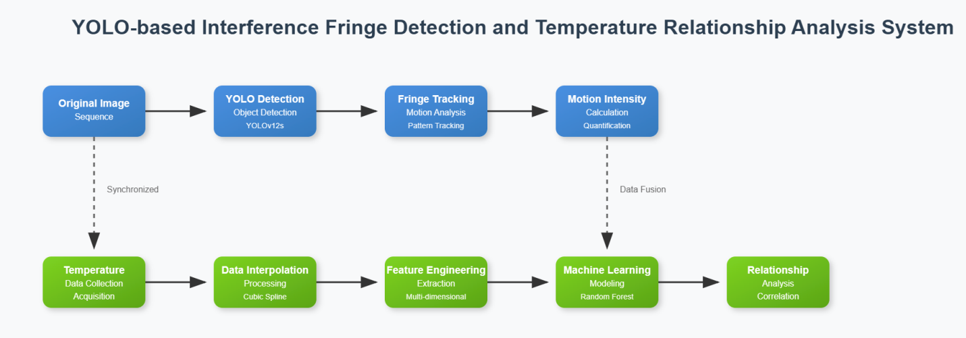

4.2 Temperature Data Interpolation
Due to the discrete nature of temperature measurements, where data was not available for every frame, a continuous temperature profile was synthesized using a piecewise interpolation strategy contingent on the frame index, denoted by $f$. This hybrid approach was designed to accurately model the different thermal dynamics observed during the experiment.
Cubic Spline Interpolation (for $f<27000$): In the initial phase of the experiment, characterized by non-linear temperature fluctuations, a cubic spline interpolation was employed. This method guarantees smoothness and continuity of the first and second derivatives of the temperature function, providing a more physically plausible model. For any given interval $[f_{i},f_{i+1}]$ between two consecutive temperature measurements, the temperature $T(f)$ is given by a cubic polynomial:
$\begin{aligned}S_{i}(f)=a_{i}(f−f_{i})^{3}+b_{i}(f−f_{i})^{2}+c_{i}(f−f_{i})+d_{i}\#(1)\end{aligned}$
where the coefficients $\{a_{i},b_{i},c_{i},d_{i}\}$ are uniquely determined by enforcing continuity constraints on $T(f)$ and its derivatives at the measurement points.
Linear Interpolation (for $f≥27000$): In the later, more stable phase of the experiment, the temperature exhibited a near-linear trend. Consequently, a linear interpolation model was adopted for its simplicity and appropriateness. The temperature is modeled as:
$$\begin{aligned}T(f)=T(f_{j})+\frac{T(f_{j+1})−T(f_{j})}{f_{j+1}−f_{j}}(f−f_{j})\#(2)\end{aligned}$$
Based on our empirical data for this phase, this simplified to the specific linear relationship:
$$\begin{aligned}T(f)=0.10000f+43.80000\#(3)\end{aligned}$$
This composite interpolation methodology ensures a high-fidelity reconstruction of the thermal environment for the entire temporal range of the dataset.

4.3 YOLO model development and training strategy

4.3.1 Customize YOLO architecture
To achieve efficient interference fringe detection, this study developed a customized YOLO model based on the YOLOv12s architecture. By introducing a custom dataset processor, the model significantly enhances interference fringe detection capabilities. The processor preprocesses input data to ensure compatibility with model requirements while optimizing data loading efficiency, thereby providing high-quality data support for model training.

4.3.2 Customized Non-Maximum Suppression (NMS)
To refine the final detection output, a customized Non-Maximum Suppression (NMS) algorithm was implemented. The core of this algorithm is the Intersection over Union (IoU) metric, calculated as:
$$\begin{aligned}\text{IoU}\text{(}{\text{box}}_{\text{p}}\text{,}{\text{box}}_{\text{g}}\text{)=}\frac{\text{Area}\text{(}{\text{box}}_{\text{p}}\text{∩}{\text{box}}_{\text{g}}\text{)}}{\text{Area}\text{(}{\text{box}}_{\text{p}}\text{∪}{\text{box}}_{\text{g}}\text{)}}\#(4)\end{aligned}$$
where ${\text{box}}_{\text{p}}$ is a predicted bounding box and ${\text{box}}_{\text{g}}$ is a ground-truth bounding box. In the post-processing step, detections with an IoU greater than a predefined threshold are suppressed, thereby ensuring that each unique fringe is represented by a single, optimal bounding box.

4.3.3 Training Strategy
During model training, we integrated multiple advanced techniques to enhance performance and generalization capabilities. The specific strategies are as follows:
- Data augmentation: To improve the model's adaptability to diverse data distributions, we employed multi-scale training, Mixup data augmentation (α=0.1), and geometric transformations. Multi-scale training enables the model to handle targets of varying sizes by training across different resolutions. Mixup enhances generalization through linear interpolation of two input samples and their labels. Geometric transformations further enrich data diversity by applying random scaling, rotation, and translation operations.
- Regularization: To prevent model overfitting, we implemented label smoothing (with a smoothing coefficient of 0.05) and weight decay (with a decay coefficient of 0.0005). Label smoothing transforms hard labels into soft labels, making the model outputs smoother and reducing overconfidence. Weight decay introduces a regularization term into the loss function to constrain the magnitude of model weights, thereby enhancing the model's generalization ability.
- Optimization: During the optimization process, we implemented a cosine learning rate scheduling strategy that modulates the learning rate according to a cosine curve throughout training. This approach enables rapid convergence in the early stages while allowing fine-tuning of model parameters in later phases. Additionally, to enhance training efficiency, we adopted mixed-precision training technology. By dynamically adjusting data precision during training, this method reduces computational resource consumption and accelerates the training process.
- Validation: To accurately evaluate model performance, we developed a customized validator with specialized post-processing. This validator performs advanced processing on model outputs, including non-maximum suppression and confidence threshold filtering, to enhance detection accuracy and reliability. Furthermore, we optimized the validator specifically for stripe detection tasks, ensuring it better meets the requirements of this particular application.

4.4 Multi-Task Composite Loss Function
The optimization of the network is guided by a composite loss function, ${\text{ℒ}}_{\text{total}}$, which linearly combines the standard YOLOv12s detection losses with a regression loss for temperature prediction. The composite loss is formulated as:
$$\begin{aligned}{\text{ℒ}}_{\text{total}} \text{=}{ \text{ℒ}}_{\text{YOLO} }\text{+} \text{α}{\text{ℒ}}_{\text{temp}}\#(5)\end{aligned}$$
where ${\text{ℒ}}_{\text{YOLO}}$ encapsulates the multi-component YOLO loss and ${\text{ℒ}}_{\text{temp}}$ is the temperature regression loss. The hyper parameter $\text{α}$ serves as a weighting factor to balance the contributions of the two tasks; in our experiments, it was set to $\text{α}\text{=1}$.
The YOLO loss, ${\text{ℒ}}_{\text{YOLO}}$, is an aggregation of three constituent losses:
$$\begin{aligned}{\text{ℒ}}_{\text{YOLO}} \text{=} {\text{λ}}_{\text{1}}{ \text{ℒ}}_{\text{box} }\text{+}{ \text{λ}}_{\text{2}}{ \text{ℒ}}_{\text{cls} }\text{+} {\text{λ} }_{\text{3}}{ \text{ℒ}}_{\text{obj}} \#(6)\end{aligned}$$
where ${\text{ℒ}}_{\text{box}}\text{,}{\text{ℒ}}_{\text{cls}}$, and ${\text{ℒ}}_{\text{obj}}$ represent the bounding box regression loss, the classification loss, and the objectness (confidence) loss, respectively. The ${\text{λ}}_{\text{i}}$ are their corresponding weighting coefficients.
The temperature loss, ${\text{ℒ}}_{\text{temp}}$ , is quantified by the Mean Squared Error (MSE) between the predicted temperature, ${\text{T}}_{\text{pred}}$, and the ground-truth temperature, ${\text{T}}_{\text{gt}}$:
$$\begin{aligned}{\text{ℒ}}_{\text{temp} }\text{=} \frac{\text{1}}{\text{N} }\sum_{\text{i}\text{=1}}^{\text{N}}{\text{(}}{\text{T}}_{\text{pred}\text{,}\text{i}} \text{−} {\text{T}}_{\text{gt}\text{,}\text{i}} {\text{)} }^{\text{2}}\#(7)\end{aligned}$$
where $\text{N}$ denotes the number of detected objects within a given batch.

4.5 Exercise intensity calculation and analysis

4.5.1 Strip Tracking Algorithm
This study employs an advanced fringe tracking system to accurately capture the motion trajectory of fringes. The system utilizes high-precision image processing technology to real-time monitor the position changes of fringes in each frame, thereby providing basic data for subsequent motion intensity analysis. Based on speed and direction, we classify the motion states of fringes into four categories: stationary, horizontal motion, vertical motion, and oblique motion. Specifically, when the speed is less than 0.5 pixels per frame, the fringe is considered stationary; when the absolute value of horizontal displacement is greater than twice the absolute value of vertical displacement, it is defined as horizontal motion, expressed as "Left/Right Shift ($\text{(}\text{v}\text{)} \text{pixels per frame}$)"; when the absolute value of vertical displacement is greater than twice the absolute value of horizontal displacement, it is defined as vertical motion, expressed as "Up/Down Shift ($\text{(}\text{v}\text{)} \text{pixels per frame}$)"; the remaining cases are classified as oblique motion, expressed in the form of "Oblique Shift ($\text{(}\text{v}\text{)} \text{pixels per frame}$, ($\text{θ}$)°)", where$\text{(}\text{v}\text{)}$is the motion speed and$\text{(}\text{θ}\text{)}$is the angle between the motion direction and the horizontal direction. This classification method can comprehensively and accurately describe the motion state of fringes, providing a clear classification basis for subsequent motion intensity analysis.

4.5.2 Motion Status Classification
To further analyze the motion characteristics of fringes, we have meticulously classified their motion states based on speed and direction. A stationary state is defined as a speed less than 0.5 pixels per frame, At this point, the fringes exhibit almost no movement. Horizontal and vertical motions are determined by comparing the absolute values of horizontal displacement ($\text{Δ}\text{x}\text{)}$) and vertical displacement ($\text{Δ}\text{y}$). When the absolute value of horizontal displacement is more than twice the absolute value of vertical displacement, the fringe is considered to be in horizontal motion, manifested as "Left/Right Shift ($\text{(}\text{v}\text{)} \text{pixels per frame}$)"; conversely, when the absolute value of vertical displacement is more than twice the absolute value of horizontal displacement, the fringe is considered to be in vertical motion, manifested as "Up/Down Shift ($\text{(}\text{v}\text{)} \text{pixels per frame}$)". For fringe motions that do not meet the above two conditions, we classify them as oblique motion, expressed in the form of "Oblique Shift ($\text{(}\text{v}\text{)} \text{pixels per frame}$, ($\text{(}\text{θ}\text{)}$)°)", where$\text{(}\text{v}\text{)}$is the motion speed and$\text{(}\text{θ}\text{)}$is the angle between the motion direction and the horizontal direction, This classification method can not only accurately describe the motion state of fringes but also provide a clear classification basis for subsequent motion intensity analysis.

4.6 Machine learning model construction and evaluation

4.6.1 Model Architecture Comparison
To comprehensively capture the relationship between temperature and movement, this study constructed three complementary machine learning models, each analyzing data from different perspectives. First, the linear regression model assumes a linear relationship between temperature and movement, using the least squares method to analyze their direct correlation. Second, the temperature-only model serves as a baseline model, employing absolute temperature as the sole input to evaluate the direct impact of temperature on movement. Finally, the random forest model, as an ensemble learning approach, captures nonlinear relationships in the data by constructing multiple decision trees to enhance predictive accuracy and robustness. Through comparative analysis of these three models, we gain a more comprehensive understanding of the complex relationship between temperature and movement.

4.6.2 Performance index
To evaluate the model's performance, this study employs multiple metrics. The $\text{R}\text{²}$ score (coefficient of determination) is used to measure the model's ability to explain the data, with the calculation formula:
$$\begin{aligned}{\text{R}}^{\text{2}}\text{=1−}\frac{\sum_{\text{i}\text{=1}}^{\text{n}}{\text{(}}{\text{y}}_{\text{i}}\text{−}\hat{\text{y}}\text{i}{\text{)}}^{\text{2}}}{{\sum{\text{i}\text{=1}}}^{\text{n}}\text{(}{\text{y}}_{\text{i}}\text{−}\bar{\text{y}}{\text{)}}^{\text{2}}}\#(8)\end{aligned}$$
where$\text{(}{\text{y}}_{\text{i}}\text{)}$is the actual value,$\text{(}\hat{\text{y}}\text{i}\text{)}$is the predicted value, and$\text{(}\bar{\text{y}}\text{)}$is the mean of the actual values. A value closer to 1 indicates a better model fitting effect. The Root Mean Squared Error (RMSE) reflects the deviation between the model's predicted values and actual values, calculated as:
$$\begin{aligned}\text{RMSE}\text{=}\sqrt{\frac{\text{1}}{\text{n}}{\sum{\text{i}\text{=1}}}^{\text{n}}\text{(}{\text{y}}_{\text{i}}\text{−}\hat{\text{y}}\text{i}{\text{)}}^{\text{2}}}\#(9)\end{aligned}$$
A smaller value indicates more accurate model predictions. The Mean Absolute Error (MAE) measures the average error between predicted and actual values, with the formula:
$$\begin{aligned}\text{MAE}\text{=}\frac{\text{1}}{\text{n}}{\sum{\text{i}\text{=1}}}^{\text{n}}\text{|}{\text{y}}_{\text{i}}\text{−}{\hat{\text{y}}}_{\text{i}}\text{|}\#(10)\end{aligned}$$
A smaller value indicates more accurate model predictions. Feature importance quantifies the contribution of each feature to model predictions, helping us understand which features have the greatest impact on model performance. These metrics evaluate the model's performance from different perspectives, ensuring a comprehensive understanding of its strengths and weaknesses.

4.7 Statistical Analysis Framework

4.7.1 Correlation analysis
To conduct an in-depth analysis of the relationship between temperature and motion, this study performed a comprehensive correlation analysis across different temperature ranges. Specifically, we first calculated the correlation coefficient and p-value for the overall data to assess the general correlation between temperature and motion. The formula for the correlation coefficient$\text{(}\text{ρ}\text{)}$is:
$$\begin{aligned}\text{ρ}\text{=}\frac{\sum_{\text{i}\text{=1}}^{\text{n}}{\text{(}}{\text{x}}_{\text{i}}\text{−}\bar{\text{x}}\text{)(}{\text{y}}_{\text{i}}\text{−}\bar{\text{y}}\text{)}}{\sqrt{\sum_{\text{i}\text{=1}}^{\text{n}}{\text{(}}{\text{x}}_{\text{i}}\text{−}\bar{\text{x}}{\text{)}}^{\text{2}}\sum_{\text{i}\text{=1}}^{\text{n}}{\text{(}}{\text{y}}_{\text{i}}\text{−}\bar{\text{y}}{\text{)}}^{\text{2}}}}\#(11)\end{aligned}$$
where$\text{(}{\text{x}}_{\text{i}}\text{)}$and$\text{(}{\text{y}}_{\text{i}}\text{)}$are the observed values of temperature and motion, respectively, and$\text{(}\bar{\text{x}}\text{)}$and$\text{(}\bar{\text{y}}\text{)}$are the mean values of temperature and motion, respectively. Subsequently, we divided the temperature data into four intervals based on quartiles and calculated the correlation coefficient and p-value for each interval. This method not only reveals the overall correlation between temperature and motion but also uncovers variations in correlation across different temperature intervals. Through this segmented analysis approach, we can gain a more detailed understanding of the relationship between temperature and motion, providing a foundation for subsequent hypothesis testing.

4.7.2 Hypothesis Testing
To evaluate statistical significance, this study employed various hypothesis testing methods. First, the Pearson correlation test was used to assess the linear relationship between temperature and motion, determining whether there is a significant linear correlation by calculating the correlation coefficient and p-value. Second, the t-test was utilized to compare motion intensities under different temperature thresholds, with the formula:
$$\begin{aligned}\text{t}\text{=}\frac{{\bar{\text{x}}}_{\text{1}}\text{−}{\bar{\text{x}}}_{\text{2}}}{\sqrt{\frac{{\text{s}}_{\text{1}}^{\text{2}}}{{\text{n}}_{\text{1}}}\text{+}\frac{{\text{s}}_{\text{2}}^{\text{2}}}{{\text{n}}_{\text{2}}}}}\#(12)\end{aligned}$$
where$\text{(}{\bar{\text{x}}}_{\text{1}}\text{)}$and$\text{(}{\bar{\text{x}}}_{\text{2}}\text{)}$are the means of the two data groups,$\text{(}{\text{s}}_{\text{1}}\text{)}$and$\text{(}{\text{s}}_{\text{2}}\text{)}$are the standard deviations, and$\text{(}{\text{n}}_{\text{1}}\text{)}$and$\text{(}{\text{n}}_{\text{2}}\text{)}$are the sample sizes of the two groups. The$\text{t}$value and$\text{p}$value were calculated to determine if there are significant differences in motion intensity under different temperature conditions. Finally, Analysis of Variance (ANOVA) was used to compare multiple groups of data across heating stages, calculating the$\text{F}$value and$\text{p}$value to assess significant differences in motion intensity between different heating stages. These statistical analysis methods provide powerful tools for verifying the significance of the relationship between temperature and motion, thereby establishing a solid statistical foundation for our research conclusions.

5. Required hardware and software
Hardware: 12GB GPU RTX 4070 Super;
Software: Data annotation tool X-AnyLabeling;
Code development tools: Python, PyCharm, Conda, Git.

6. Project planning
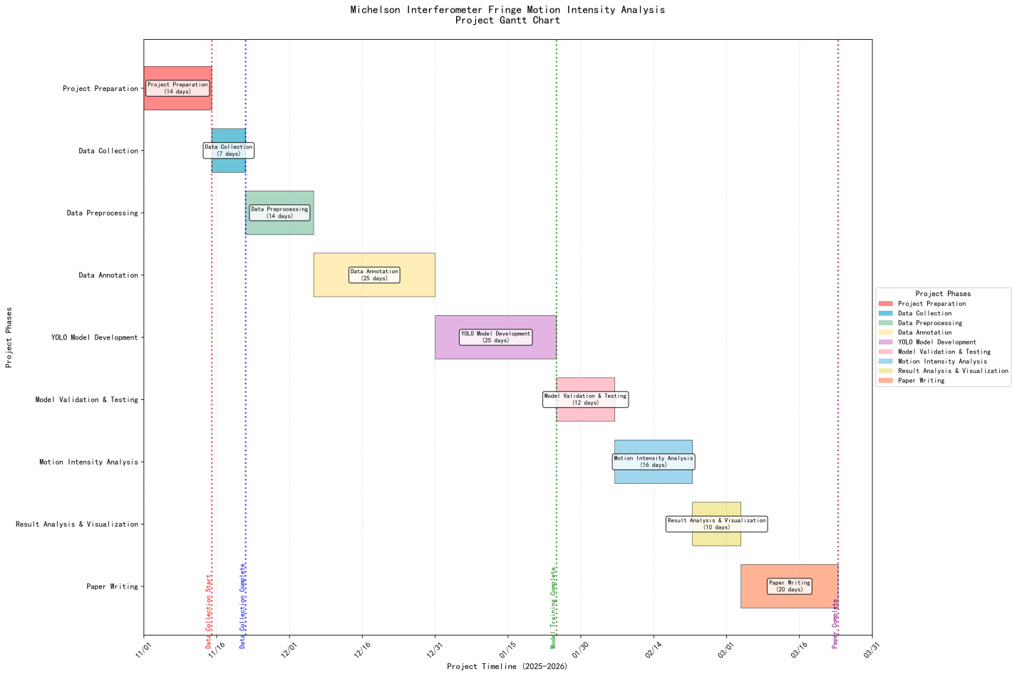

References
- Wikipedia contributors. "Michelson interferometer." Wikipedia, The Free Encyclopedia. Wikipedia, The Free Encyclopedia, 1 Oct. 2025. Web. 29 Oct. 2025.
- Redmon J, Divvala S, Girshick R, et al. You only look once: Unified, real-time object detection[C]//Proceedings of the IEEE conference on computer vision and pattern recognition. 2016: 779-788.
- Girshick R, Donahue J, Darrell T, et al. Rich feature hierarchies for accurate object detection and semantic segmentation[C]//Proceedings of the IEEE conference on computer vision and pattern recognition. 2014: 580-587.
- Redmon J, Farhadi A. YOLO9000: better, faster, stronger[C]//Proceedings of the IEEE conference on computer vision and pattern recognition. 2017: 7263-7271.
- Redmon J, Farhadi A. Yolov3: An incremental improvement[J]. arXiv preprint arXiv:1804.02767, 2018.
- Bochkovskiy A, Wang C Y, Liao H Y M. Yolov4: Optimal speed and accuracy of object detection[J]. arXiv preprint arXiv:2004.10934, 2020.
- Ultralytics, “YOLOv5 documentation,” https://github.com/ultralytics/yolov5, 2021.
- Gurrola-Ramos J, Dalmau O, Alarcón T. U-Net based neural network for fringe pattern denoising[J]. Optics and Lasers in Engineering, 2022, 149: 106829.
- Shi J, Zhu X, Wang H, et al. Label enhanced and patch based deep learning for phase retrieval from single frame fringe pattern in fringe projection 3D measurement[J]. Optics express, 2019, 27(20): 28929-28943.
- 吴荣, 汪剑伟, 谢锋云. 基于深度学习的激光剪切散斑干涉无损检测缺陷识别[J]. 激光与红外, 2023, 53(8): 1156-1162.

